WebSIS for Instructors

http://student.mit.edu/

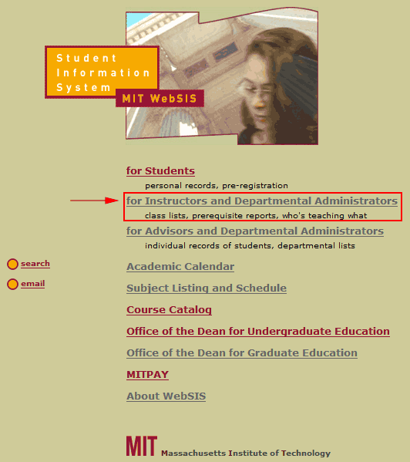

WebSIS – Instructor-specific area

https://student.mit.edu/cgi-docs/sfprwscl.html
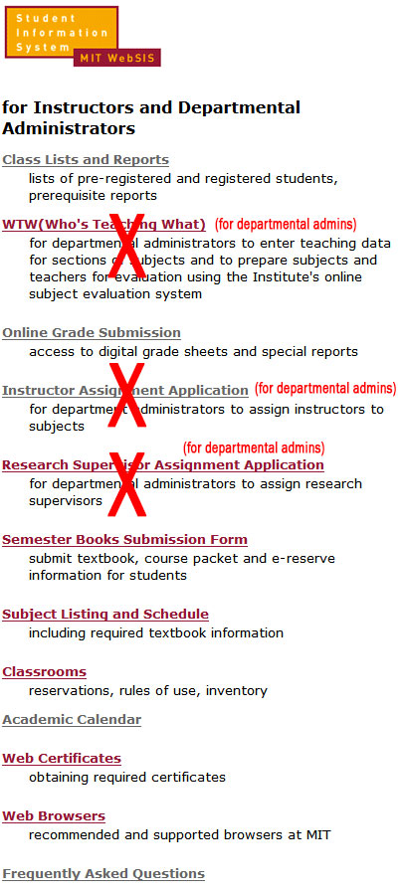

Class Lists and Reports for Instructors
https://student.mit.edu/cgi-docs/sfprwscl.html
There are several options in the Class Lists & Reports area:

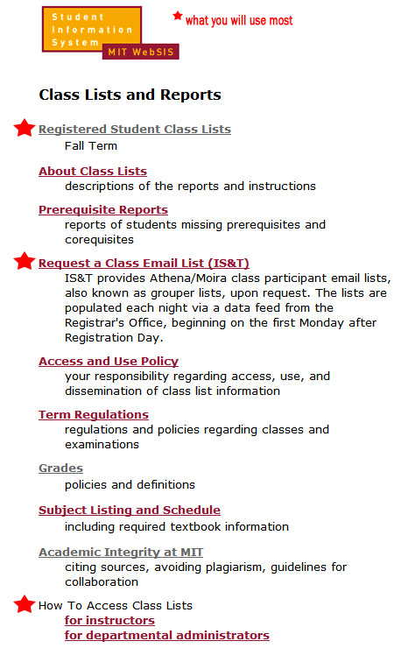

Class Lists and Reports → Registered Student Class Lists
https://student.mit.edu/cgi-bin/sfprwlst_sel.sh - Search for a class list,/send email to class/download photos.
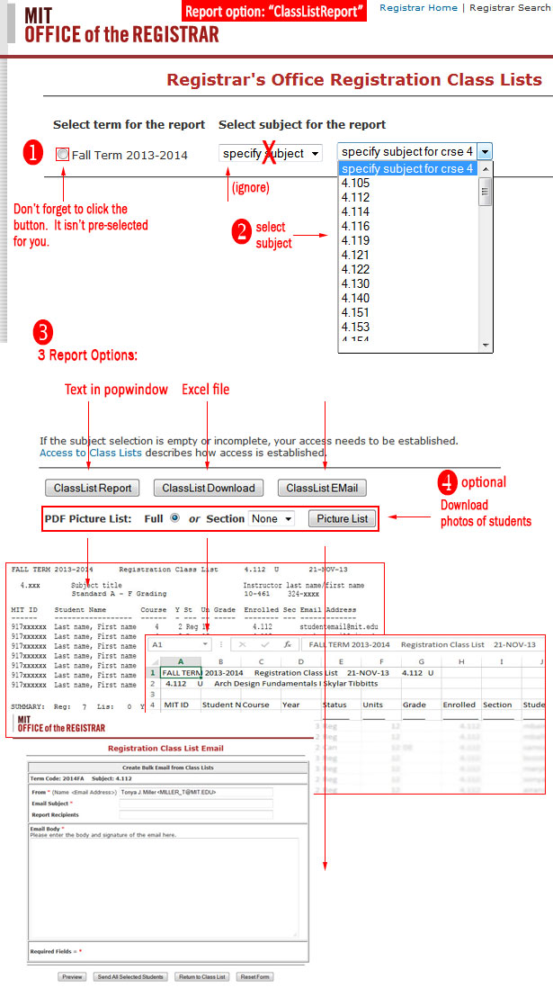

Snapshots of available report formats

This appears in a pop-up window in your browser:

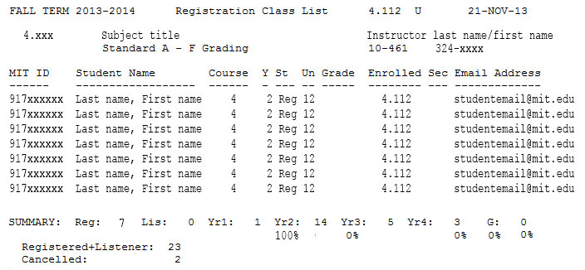

Results in an Excel file:

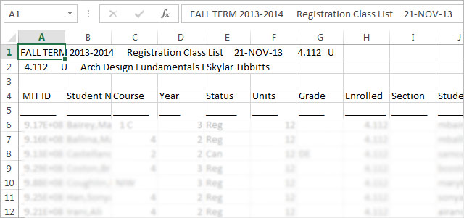

Results in an email form where you may email your entire class:

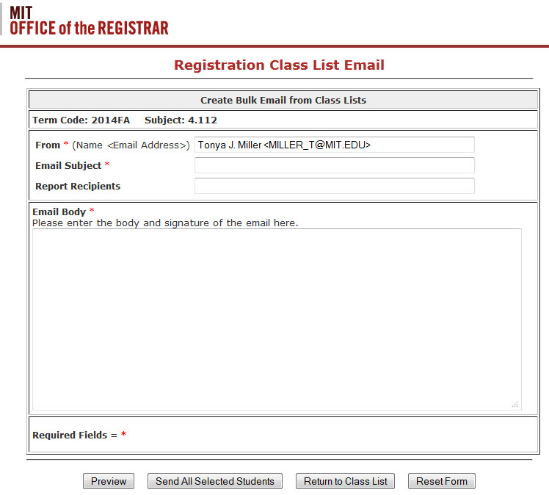

Results in a pop-up window showing your students’ photos and general information:

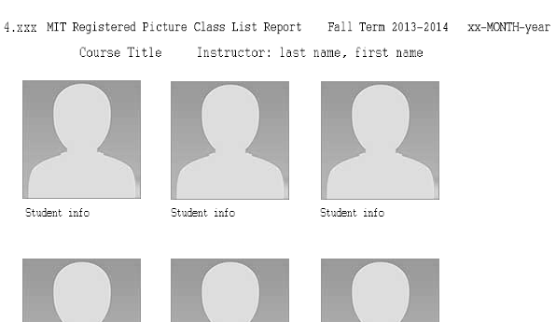

[END Class Lists and Reports for Instructors]

Online Grade Submission
https://ogs.mit.edu/ogs/

You will most likely only use the “Grade Entry” section

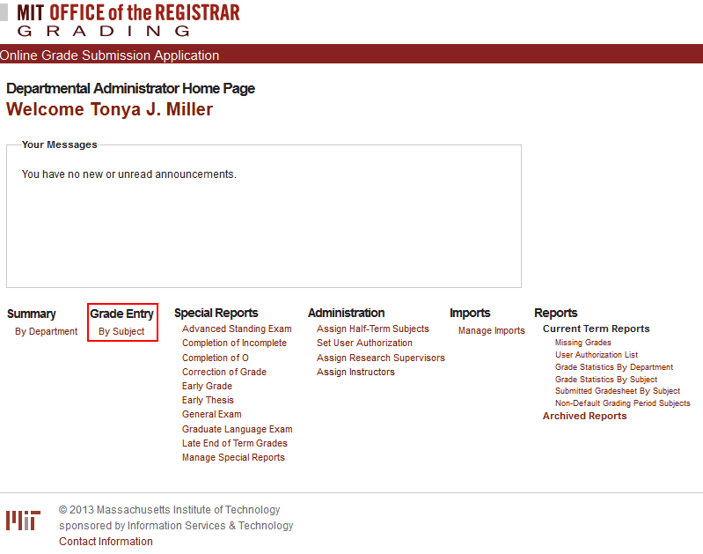

[END Online Grade Submission for Instructors]

[END Grading for Instructors]

Semester Books Submission Form (aka TIP)
http://tip.mit.edu/
See TIP detailed instructions (PDF)

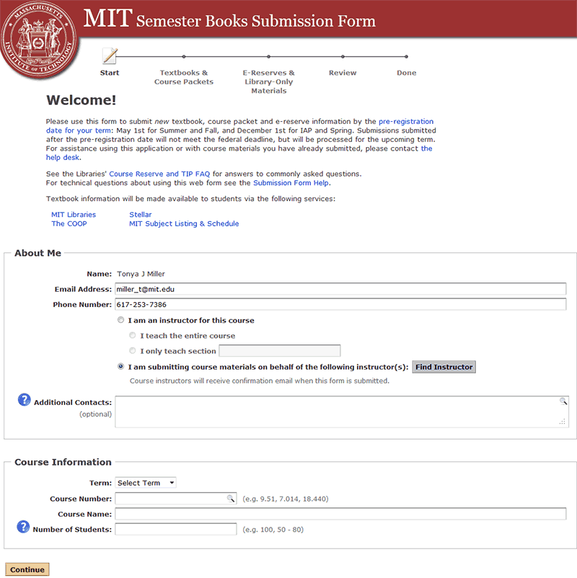

[END Semester Books Submission (TIP) for Instructors]

Subject Listing and Schedule
http://student.mit.edu/catalog/m4a.html
Click “Course 4 – Architecture”

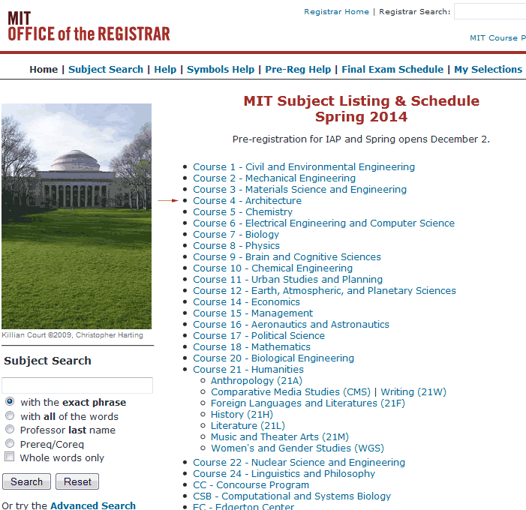

There are links to each of the Department’s Discipline areas (see below). The descriptions here are the catalog descriptions we ask for when a new class is listed. These are short and very generic versus the subject description for the Department website.

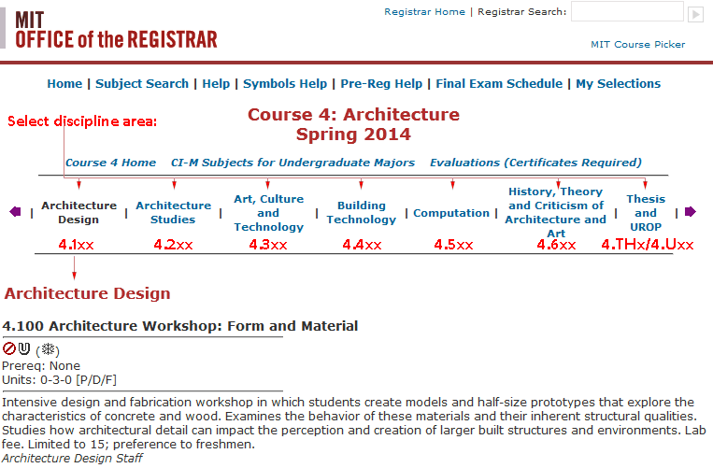

[END Subject Listing and Schedule for Instructors]

Classrooms
http://web.mit.edu/registrar/classrooms/index.html
There is a page on the Department’s Faculty Handbook website which is more succinct - http://arch-fac-site.scripts.mit.edu/faculty/scheduling/classrooms/. It includes information on Department rooms as well and has a direct link to the Institute’s room reservation form.

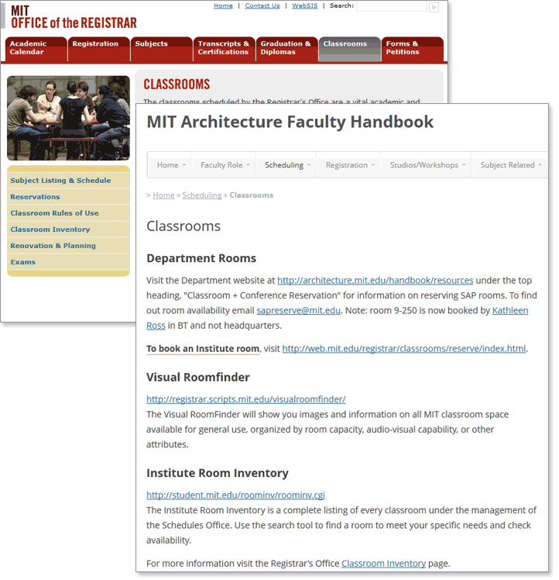

[END Classrooms for Instructors]

Academic Calendar
http://web.mit.edu/registrar/calendar/index.html

View and/or download Institute academic calendars in various forms. There is also a Department-specific calendar on the Faculty Handbook website that lists important Department dates/deadlines with major Institute dates included. Also on the Handbook website is a PDF download of “Key Dates for Faculty”.

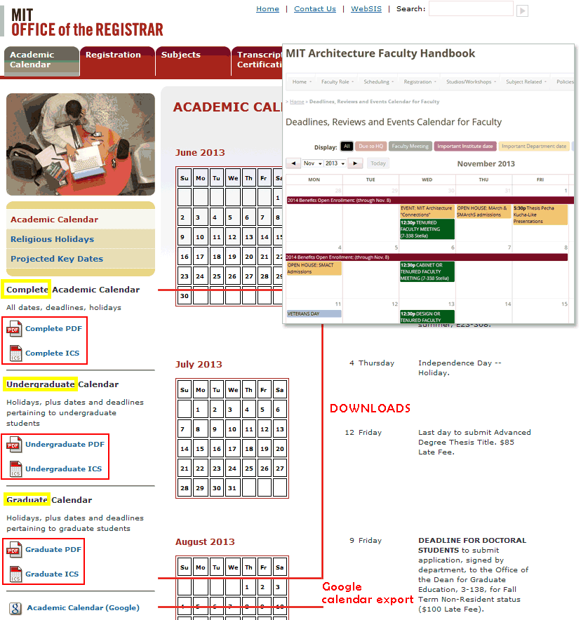

[END Academic Calendar for Instructors]

Web Certificates
http://ist.mit.edu/certificates

You will need web certificates to access many administrative areas of WebSis.

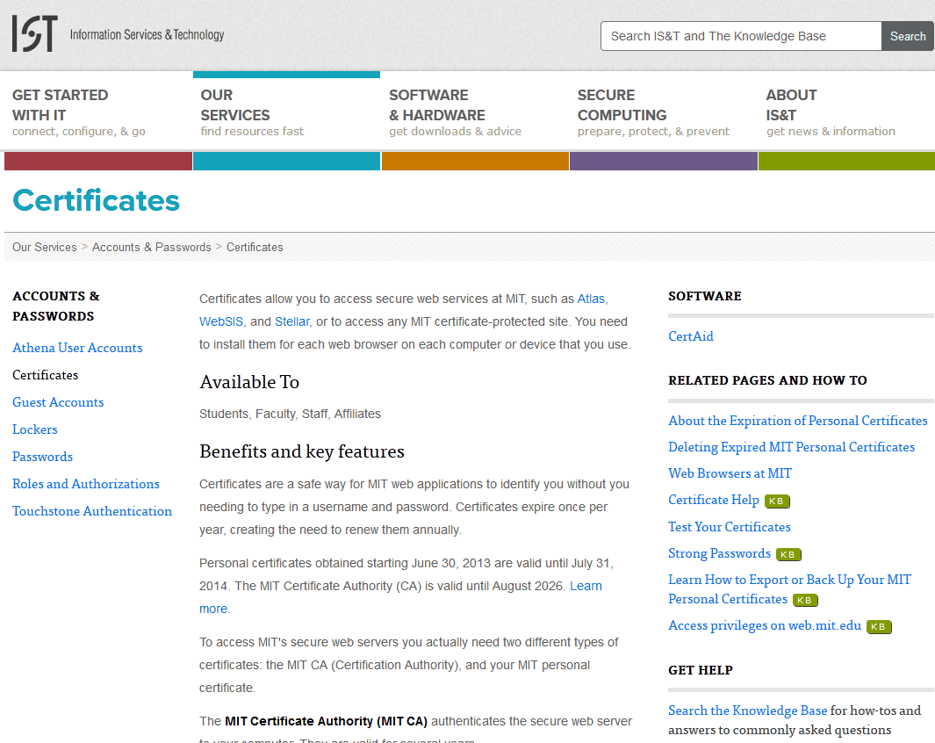

[END Certificates for Instructors]

Frequently Asked Questions
http://student.mit.edu/cgi-docs/webfaqs.html

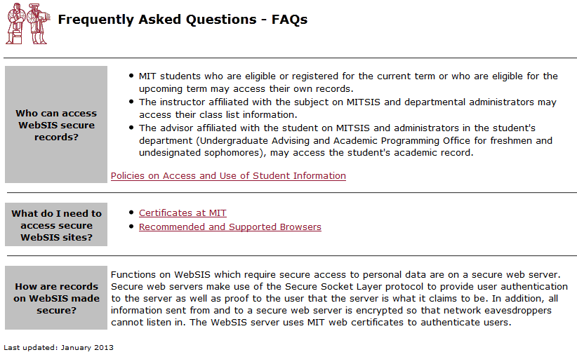

[END WebSIS FAX for Instructors]

[END WebSIS for Instructors

